CS 255 System Design Document Template

UML Diagrams

UML Use Case Diagram
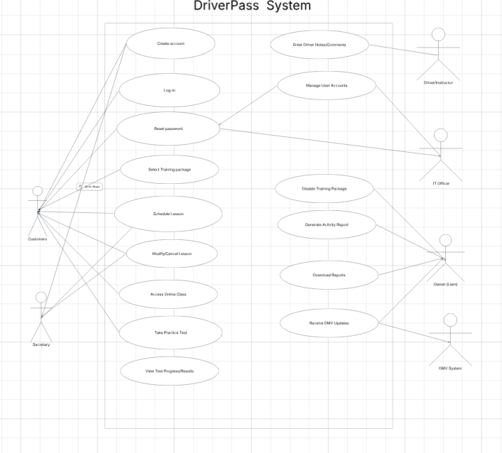

UML Activity Diagrams

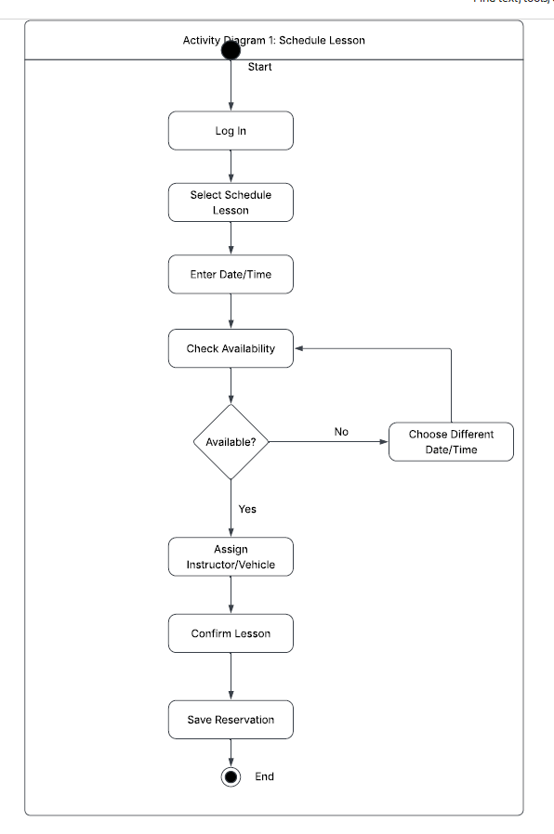
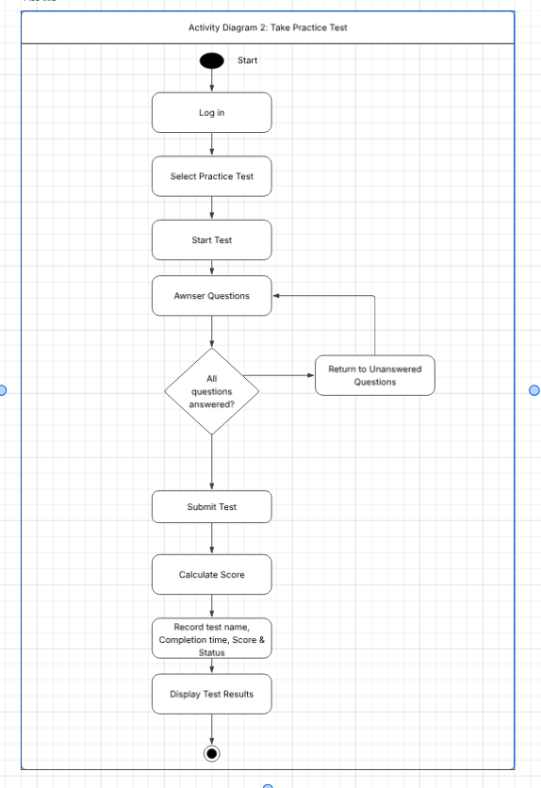

UML Sequence Diagram
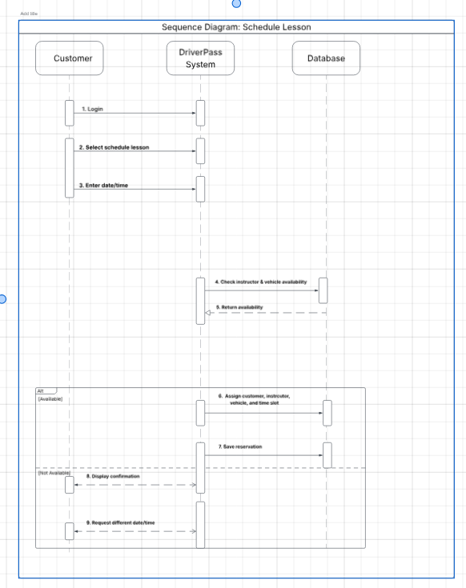

UML Class Diagram
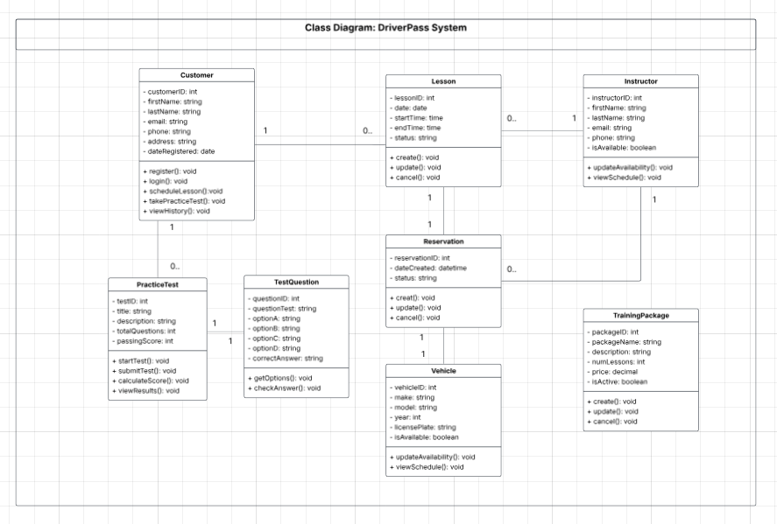

Technical Requirements
The DriverPass system will be web-based so customers and employees can access it from a computer, tablet, or mobile device using a supported web browser. Users won’t need to install special software. The system should be hosted in the cloud, which will give DriverPass access from different locations while also supporting backups, availability, and basic infrastructure security.

A centralized database will be needed to store customer accounts, training packages, appointments, instructor and vehicle information, test results, lesson notes, and activity records. The system also needs a secure connection to receive updated DMV rules, policies, and sample questions. Access should be based on each user’s role, and sensitive information such as passwords and payment information must be protected while being stored and transmitted.

DriverPass employees will need standard computers or mobile devices with internet access, while customers can use their own supported devices. Development and design tools such as Lucidchart can be used to model the system before implementation. The final system should support multiple users at the same time and update appointment availability as soon as a lesson is created, changed, or canceled.

